**微信临时入住登记指南**

**Guide for Registration for Temporary Residence via Wechat**

1. 微信关注“南京公安”微信公众账号，或扫描以下二维码关注

Search for “NJgongan”and follow up the Wechat Account called “南京公安”

You can also scan the QR code below

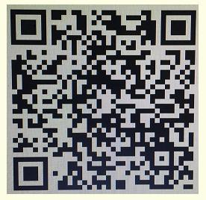

1. 进入微信公众号后，点击“微服务”

Click on“微服务”

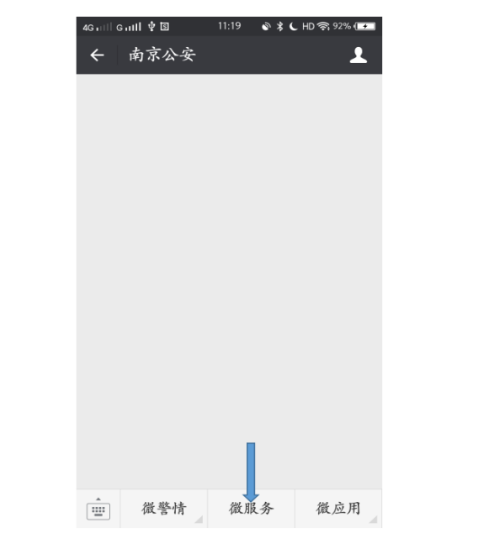

1. 点击“出入境”以及“境外人员临时住宿登记”

Click on“出入境”and then click on“境外人员临时住宿登记”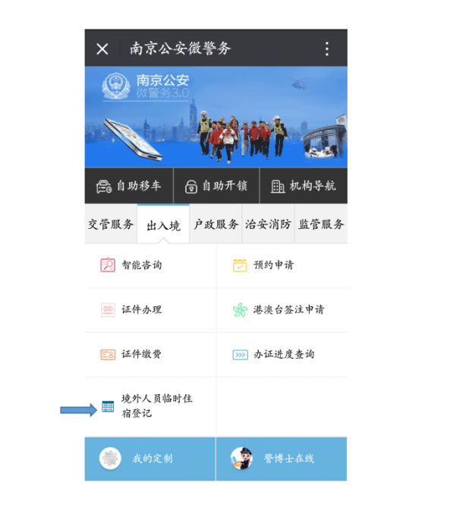

1. 阅读“申报须知”后，点击“同意”

After reading the notice, click on “Agree”

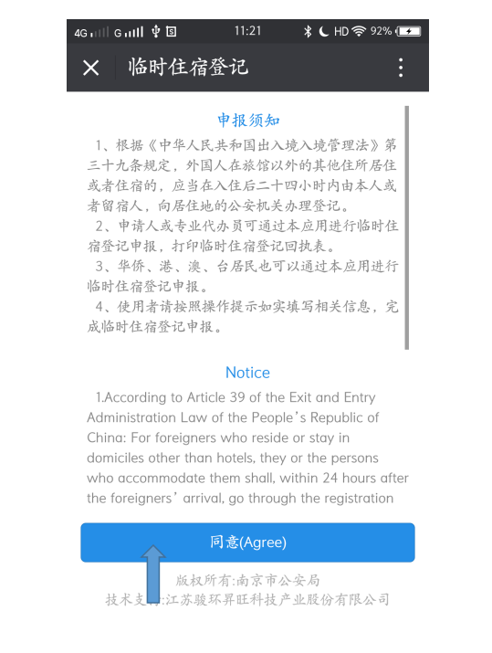

1. 点击本人申报，按要求完成微信临时入住登记

Click on “My Registration” and then follow the instructions to finish registration.

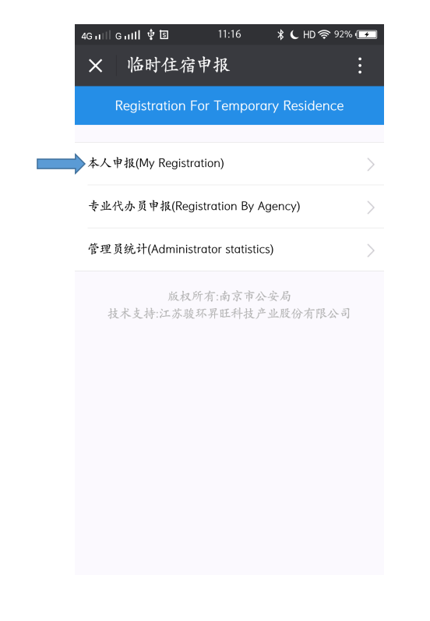

1. 登记成功后，将会在公众账号界面收到如下回执单，点击下载PDF版本回执单后发给相应的辅导员老师。回执单“以姓名+临时住宿登记表”命名

After registration, you’ll receive a message. The following message shows that your temporary residence registration has been approved. You can download the online registration form by clicking on “下载回执单” and send a copy of that to your head teacher, thanks~

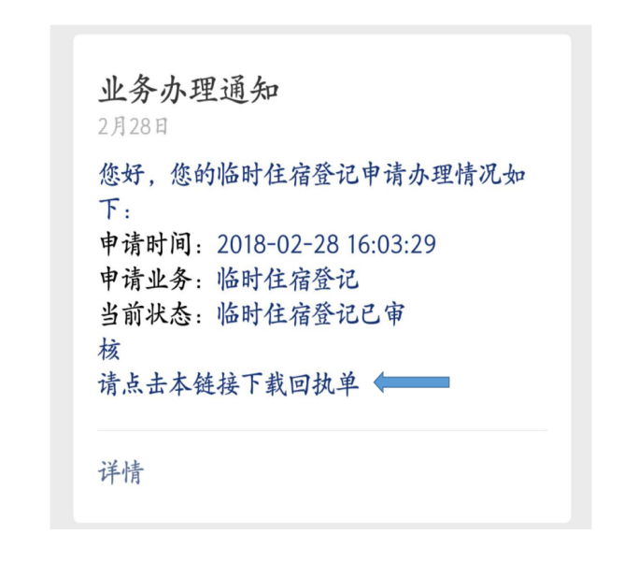

Tips：you need to download a Chinese Keyboard for filling in some columns in Chinese

中国境内联系人Contact in China: 填写辅导员姓名

中国境内联系方式Phone Number Used in China：填写辅导员联系方式

下一站目的地 Next destination: 南京

在宁单位 Unit in Nanjing: 南京审计大学

住宿地址Address in China: 江苏省南京市浦口区江浦街道雨山西路86号