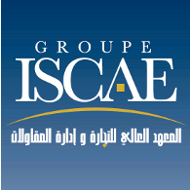 | Booklet for International Students | Réf : ENR_PRO_SYS02/02
 | Booklet for International Students | Version : 02  Date : 03/04/2015
 | Booklet for International Students | Page : 12/12

- General Information

Contacts/ Groupe ISCAE

Mohamed El MOUEFFAK
General Manager
Tel : +212 (0)5 22 33 54 93
Fax : +212 (0)5 22 33 54 96
Elmoueffak58@yahoo.fr

Samira ALAOUI
Head of the International Relations
And Communication Department
Tel: +212 (0)5 22 33 54 92
Fax: +212 (0)5 22 33 54 96
salaoui@groupeiscae.ma

Lamiaâ MAKROUM
International Relations Office Assistant
Tel: +212 (0)5 22 33 54 91
Fax: +212 (0)5 22 33 54 96
lmakroum@groupeiscae.ma

Mohamed RIAD
Intendant
Tel: +212 (0)5 22 33 54 91
Fax : +212 (0)5 22 33 54 96
Riad@groupeiscae.ma
riadmohamed11@yahoo.fr

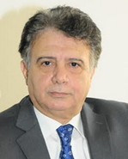

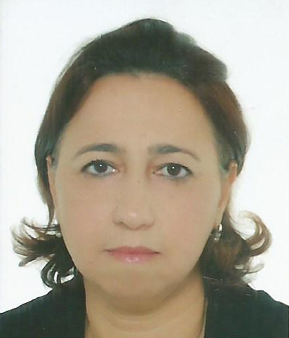



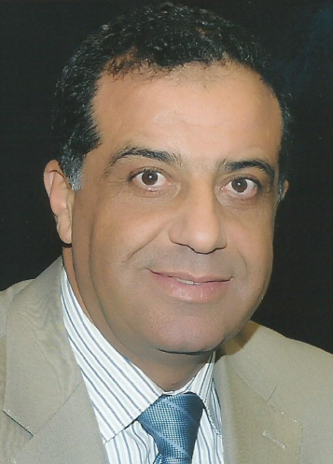

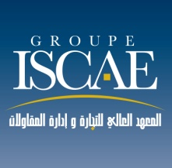

Contacts/ ISCAE-Casablanca

Nada BIAZ
Director
Tel : +212 (0)5 22 33 54 95
Fax : +212 (0)5 22 33 55 05
nbiaz@groupeiscae.ma

Contacts/ ISCAE-Rabat

Mohamed Jaouad EL QASMI
Director
Tel: +212 (0)5 37 71 20 47
Fax: +212 (0)5 37 71 23 67
emj37@hotmail.com



« Groupe ISCAE » Presentation

“Groupe ISCAE”, the first Moroccan Business School, was created in 1971 to answer a growing need for high executives expressed by Moroccan enterprises.

“Groupe ISCAE”, a public institution is considered as a civil body with financial autonomy.

“Groupe ISCAE” is supervised by the Ministry of Trade and Industry.

The Board of Directors includes the Ministry of Trade and Industry (President), the Minister of Higher Education, the Minister of Finance, the President of Moroccan Confederation of Enterprises, President of 3 big Public Enterprises and 3 big Private Companies, the Dean of University Hassan II, the Presidents of the advisory council of Casablanca and Rabat regions, President of chambers of Trade and Industry’s federation, the CEO of “Groupe ISCAE” and 3 Professors elected by the professoral corps.

The “Groupe ISCAE” includes:
- ISCAE – Casablanca,
- ISCAE – Rabat : since 1995, ISCAE opened an annex in Rabat offering most of the programs offered in Casablanca,
- ISCAE – Conakry (Guinea) created in 2002.
- ISCAE – Fes, which will open in 2015-2016.
Programme
      - Academic Training
  - Doctorate School
  - “Grande Ecole” (Post Graduate Program that delivers Groupe ISCAE’s Diploma / Grade Master).
  - Chartered Accounting Program
  - Executive MBA
  - Master with dual degree :
Management of cities and territories
Accounting, Auditing and Management Control
Human Resources Management
Finance
Public Management
Corporate Law
International Business
Marketing
Marketing and Communication
Sports Management
Global Purchasing and Logistics.

- Executive Training

  - Customized inter and intra enterprise programs.
  - Certificates of specialization and further Education Programs.
- Distance Learning in Public Accounting with CNAM – INTEC

Academic Calendar
Calendar | Fall Semester | Spring Semester
Application | May 1st – June 1st | October 1st – November 1st
Admission | June 15th | November 15th
Semester Begins  Classes End | September 22nd  January 10th | January 12th  May 30th
Transcript to be sent | Late January  Early February | Late July

Fast Facts

- Exchange levels: Postgraduate (2nd and 3rd year), undergraduate (1st year)
- Language of study: English, French and Arabic
- Language requirement: none
- Group’s website: www.groupeiscae.ma
- Length of exchange: semester or academic year

Main Study Field

- Corporate Finance;
- Auditing, Accounting and controlling ;
- Market Finance;
- Marketing;
- Human Resources Management.
Accreditation

- "Groupe ISCAE" is a member of EFMD, AMBA, AACSB and AUF, AABS
- The Group has embarked on an ambitious process of certification of the educational system as EQUIS, AACSB and EPAS standards.
- The accreditation of the Executive MBA of Groupe ISCAE process officially started in April 2010 and is currently at the final step of Evaluation :
- The administration’s activities are certified ISO 9001v2008.

Grading System

The grading system in Groupe ISCAE proceeds by modules system which is a unit of studythat contains from one to three subjects, the grade is a GPA of the different evaluations duringthe semester.
✓ The module is considered validated if its grade is equal or above 10/20, and none of subjects affiliated to the module is under 7/20.
✓ The semester can be acquired by compensation if the student validates the semester of the concerned module.
N.B: If the student fails at first session, a second session is organized.
Semester is considered succeeded if the GPA of the entire modules is equal or above 10/20, and none of modules is under 8/20.

Ranking

“Groupe ISCAE” participated in the third edition of EDUNIVERSAL GLOBAL RANKING
of the best 4000 Masters and MBA in 30 specializations, The results were as followed:
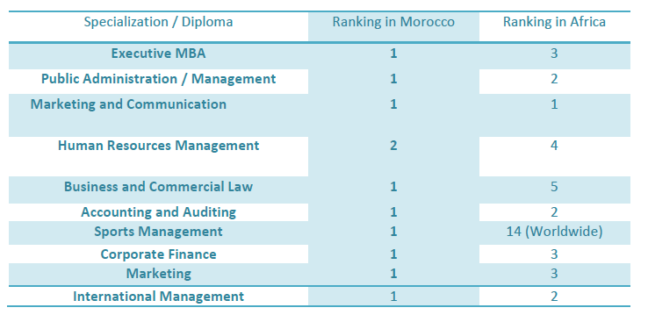
- Application

Requirements: Students who wish to study in “Groupe ISCAE” for a semester or a year must fill the following application:

GROUPE INSTITUT SUPERIEUR DE COMMERCE ET D’ADMINISTRATION
DES ENTREPRISES

Application FORM

SEMESTER EXCHANGE AT ISCAE (Academic Year : …………..)

PERIOD Fall Semester: from September to January
Spring Semester: from January to June

PERSONAL INFORMATION

First Name : ………………………………… Family Name : ………………………………
Date of Birth: ….…/……./…..……. Place of birth: ………………..………… Country : ………………….
Nationality : ………………………. Gender : M ❏ F ❏
Email of student: …………………………… Phone N° : ………………………………………….
Passport N° : ………………………………...

ACADEMIC INFORMATION

Seeked degree  Undergraduate
❑ Post graduate
Languages studied : ………………………………………………………………………………………………..

UNIVERSITY

Name : …………………………….……………………………….............................................................………………..
Address : …………………………………………………………………………….................................…………………………
…………………………………………………………………………………….....................................……………………………
City : ……………….……............. Country : …………………..................................................................…
Phone : ……………………………..... Fax : …………………......................................................................…...
E-mail : …………………………………...........................................................................................................
Academic contact : Name…………………..………………………Position…………………………………………………….
Phone N°………..…………………..……….e-mail……………………………………………………….

FAMILY
Name and Occupation of parents or guardian:
Father : …………………………………............... Mother : …………………………….....Guardian :……………………..
Phone number in case of emergency: ………………………………………...............................................…….
Phone : …………………….………………….. Fax : ………………………….…….. Mobile : …………………….………
Email Parent or Guardian : ……………………………………………………………………….
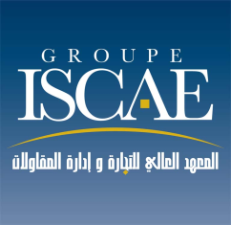

SUPPLEMENTARY DOCUMENTS TO BE ATTACHED TO APPLICATION :
- Latest school report

Please mark the chosen subjects
Subjects | Semester (*) | Number of hours | ECTS
Financial Accounting | S1 | 36 h | 4.5
Marketing 1 | S1 | 36 h | 4.5
Business English & Communication | S1 + S2 | 36 h | 4.5
Finance1 | S2 | 36 h | 4.5
Human Resources Management | S2 | 36 h | 4.5
Professional project | S2 + S4 | 48 h | 6
Leadership | S3 | 36 h | 4.5
Strategic Management | S3 | 36 h | 4.5
Customer Behavior | S4 | 36 h | 4.5
Management Control | S5 | 36 h | 4.5
Islamic Finance | S5 | 36 h | 4.5
International Finance | S5 | 36 h | 4.5
Capital Markets | S5 | 36 h | 4.5
Customer Relationship Marketing | S5 | 36 h | 4.5
E-Marketing | S5 | 36 h | 4.5
Specific Marketing | S5 | 36 h | 4.5
Introduction to Arabic language and culture |  | 36 h | 4.5
Introduction to French language |  | 36 h | 4.5

- (*) S1 : Fall Semester / year one of Grande Ecole (third undergraduate)
- (*) S2 : Spring semester / year one of Grande Ecole (third undergraduate)
- (*) S3 : Fall semester / year one of Master degree
- (*) S4 : Spring semester / year one of Master degree
- (*) S5 : Fall semester / year two of Master Degree
- (*) S6 : Spring semester / Internship

If you are seeking an undergrad degree, you may register for any of the S1, S2, S3 and S4 courses, even if some are post graduate level.

If you are seeking a graduate degree, you recommend that you register for S3, S4 and S5 courses.

In general, exchange students coming to ISCAE choose 4 business related course and 2 courses related to French language, Arabic language or introduction to Moroccan/Arabic culture and Economy.

COURSES IN FRENCH LANGUAGE:
If you are interested in courses taught in French, you will find below the list of all courses listed by semester.
Première année Grande Ecole (post-prépa ou par admission parallèle après la deuxième année de l’enseignement supérieur)
En S1 (Tronc commun)
Comptabilité Financière
Droit des Affaires
English Business*
Initiation à la Comptabilité Générale
Management de l’Entreprise
Marketing I
Sociologie
Statistiques décisionnelles
Technologie et Système d’Information
En S2 (Tronc commun)
Bases de Données
Droit Social
Economie Nationale et Internationale
English Business*
Finance I*
Fiscalité I
Gestion des Opérations
Gestion des Ressources Humaines*
Initiation à la Comptabilité Analytique
Master M1 (deux semestres S3 et S4)
En S3 (Tronc commun)
Leadership*
Choix des investissements
Comportement Organisationnel
Strategic Management*
Economie Industrielle

Marketing II

Matières optionnelles
Analyse Financière
Economie et Entreprise
Entrepreneuriat

En S4 (Par Majeure)
Matières transversales communes à toutes les majeures
RSE
Change Management*

Majeure Audit et Contrôle de Gestion
Matières obligatoires
Comptabilité de gestion
Comptabilité approfondie
Audit 1
Théorie de la finance d’entreprise
Evaluation d’entreprise
Fiscalité II
Matières optionnelles
Théorie de portefeuille
Modélisation et optimisation
Gestion de trésorerie

Majeure Finance
Matières obligatoires
Théorie de la finance d’entreprise
Modélisation et optimisation
Evaluation d’entreprise
Gestion de la trésorerie
Fiscalité II
Comptabilité approfondie
Matières optionnelles
Comptabilité de gestion
Audit I
Théorie de portefeuille

Majeure Marketing

Matières obligatoires
Marketing Stratégique
Marketing International
Stratégie de la communication
Recherche Marketing et Analyse des Marchés
Marketing Touristique
Comportement du Consommateur
Forces et techniques de vente

Master M2 (deux semestres S5 et S6)
En S5 (Par Majeure)

Matières transversales communes à toutes les majeures
Méthodologie de recherche

Majeure Audit et Contrôle de Gestion
Matières obligatoires
Fusions et Acquisitions
Management Accounting*
IFRS*
Audit II
Audits sectoriels
Management et contrôle bancaire
Matières optionnelles
Consolidation
International finance*
Finance Islamique*

Majeure Finance
Matières obligatoires
Fusion et Acquisition
Management Accounting *
IFRS*
International Finance*
Capital Markets*
Produits dérivés
Matières optionnelles
Audit II
Management et contrôle bancaire
Finance Islamique*

Majeure Marketing

Matières obligatoires
Specific marketing*
Marketing des services
Gestion de la distribution
Management de l’innovation
Politique de communication
Customer Relationship Management CRM*
Matières optionnelles
Digital marketing*
Finance islamique*
Marketing Employeur (marketing RH)

En S6

Stage de fin d’étude et thèse professionnelle
-----------------------------------------
*Cours dispensé en Anglais

PROCEEDINGS OF TRANSMISSION:
Request to be forwarded by the institution by mail + 01 copy by email to :
Monsieur Mohamed EL MOUEFFAK, Directeur Général du Groupe ISCAE
Samira ALAOUI, Directrice des Relations Internationales et de Communication-PI
Km 9,5 Route de Nouasseur B.P. 8114 Casa-Oasis
E-mail: elmoueffak58@yahoo.fr and salaoui@groupeiscae.ma
Tél: 00 212 5 22 33 54 92
Fax : 00 212 5 22 33 54 96

- Other Information

Accommodation

- In campus housing, double rooms, for two students : 500 MAD per person, per month
- Insurance Fees : 100 MAD Per Person by Semester
- Library Expenses : 100 MAD per Person by Semester
- Restaurant Expenses : 50 MAD for the access pass, per Person/Semester
- Meal Expenses: 25 MAD Per Day (Breakfast, Lunch and Dinner), it’s a symbolic Price.
- Other Loads (Power, Water...): 150 MAD by Semester/person.
- Internet : Free Wi-Fi
- Extra (excursions, visits or personal expenses): an estimated amount of 10 000 to 12500 MAD per semester. This is a suggestion and not an obligation.

