**The 5th Campus Marathon of Nanjing Audit University Online registration and activity details**

Participants of this activity need to download the app called "咪咕善跑". The accumulated distance of outdoor running is set as 5km. You can choose anytime to run from May 8, 2021 to May 9, 2021. After you finish running, you will get an e-certificate for the healthy running activity.

**1. Registration**

Scan the registration QR code and use your mobile phone number to register for this activity. After successful registration, download the app called "咪咕善跑", and use your mobile phone number to log onto the app.



**2. How to Use the App**

You can choose a suitable time for running from May 8, 2021 to May 9, 2021. Before you start running, open the "咪咕善跑" app, click the home interface 【运动（sports）】-【跑步（running）】- select【户外跑步（outdoor running）】function - click the orange start button to carry out outdoor sports. After you finish running, long press the end button to submit and upload the exercise record.

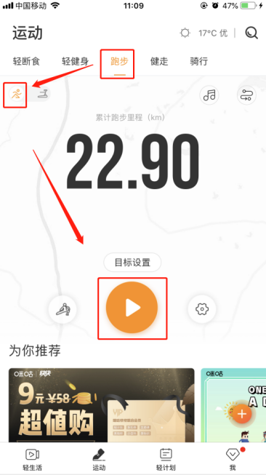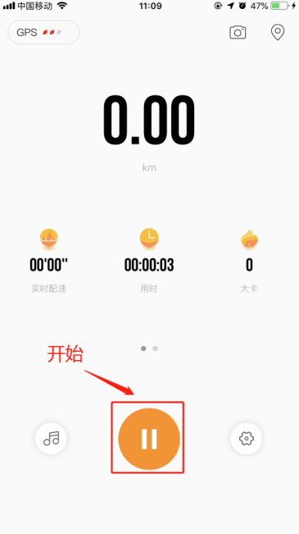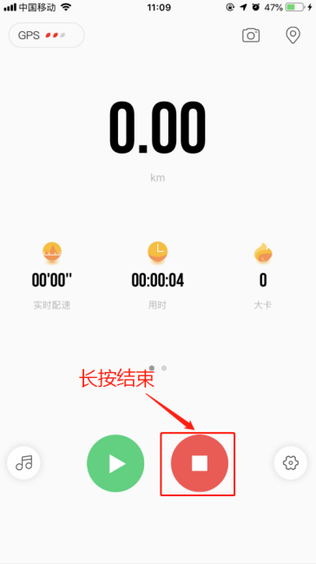

**3. Check the e-certificate after the competition**

After you finish running, you will get an e-certificate for this activity. You can click the activity registration link or scan the QR code to enter the activity page to check the certificate.

